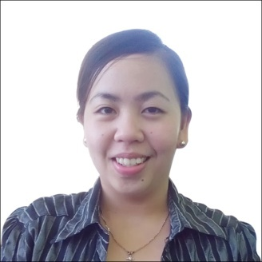

**Jay Marie D. Renejane**

**Lagang Ocana Carcar City Cebu**

**# 09065176473/09234093252**

**Email Add:** [**renejanejaymarie@gmail.com**](mailto:renejanejaymarie@gmail.com)

**PERSONAL SUMMARY**  
  
 An ambitious, highly motivated and energetic account executive with excellent marketing and business development skills. Experience of managing sales in my respective accounts. Results orientated professional with a proven ability to get results, generate revenue, improve service as well as reduce costs. With 2 years marketing experience of working in competitive industries and successfully identifying, developing and managing new business opportunities within these markets.  
  
**CAREER HISTORY**  
  
Account Executive – FERNANDO MEDICAL ENTERPRISES  
JUNE 2013 - present  
Involved in the strategic market planning for the companies services, as well as being in charge of the sales team. Organized sales promotion and demonstration of product lines.

* Represented the company at trade fairs and exhibition
* Distributed and launched company products to over 50 accounts
* Involved in developing a new sales incentive scheme that was adopted across our company.
* Responsible for forecasting market trends.
* Making sure products and services are supplied to customers on time.
* Involved in the training of new sales staff.
* Awarded as top 1 national sales and top 2 for international product distributed.
* Able to hit YTD annual sales target.
* Negotiated loyalty program with our national vendors.
* Researching the market for related products.
* Arranged client demonstration.
* Regularly liaised with our suppliers to ensure the progress of existing orders.
* Involved in the recording and administration of sales by forwarding reports and copies to the sales office.
* Provided customers with competitive quotations.

**PROFESSIONAL EXPERIENCE**  
  
Marketing

* Experience of territorial marketing, account management and client relations and retention.
* Writing detailed sales forecast report for senior company managers.
* Gathering industry data and analyzing spend patterns to highlight the potential for future growth.
* Communicating new products to potential clients.
* Proven ability to maximize sales opportunities by creating professional sales script and building rapport with potential new and also existing customers.
* Willing to accept responsibility and be accountable.
* Created a regional sales reporting and performance monitoring system
* Monitoring and reviewing the performance of sales teams, to ensure targets are met.
* Responsible for monitoring sales levels and patterns on a weekly and monthly basis to identify and predict any potential problems.

**KEY COMPETENCIES AND SKILLS**

Business development  
Product advertising  
Loss prevention  
Planning  
Promotions  
Competitor analysis  
Site selection  
Negotiating  
With valid non professional drivers license  
  
  
**REFERENCES**   
  
**Andrew Villaverde PEB STEEL BUILDING CEO #09175297111**

**Eli ar Belarmino Medical Director VCMMC-# 09473453925**

**Bernie O.Mangibin Sales Manager FMEI - #09175636792**